Title of your project
Name
Date
Class period
Work hard. Be nice.
Richards Middle School

Table of Contents
Introduction…………………………………………………………………………………………………………………………………….………3
Materials and Methods……………………………………………………………………………………
Results………………………………………………….
Discussion……………………………………………………………………
Conclusion………………………………..
Credits……………………………………………..
References…………………………………………………………

Introduction
Question:

Hypothesis:

What made you decide to research your project?

What do you hope to gain from the research?

Materials and Methods
Materials:

Methods:
List procedure here.
What did you do?
How often?
What measurement tools did you use and why?
The paper should be in so much detail that ANYONE that picks up your paper and reads it could replicate your project (make sure to delete this before turning in.
You may add pictures of equipment here.

Results
Data tables:

Graphs: (this is an example)
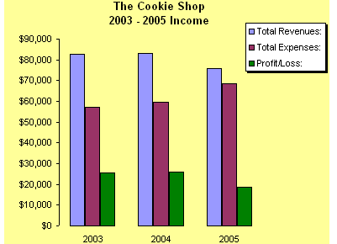
- Any data tables, graphs created from data, raw data, and observations… all are included here!

Discussion
Compare what happened in your experiment to what you expected.

Discuss possible errors

How did the data vary between observations/trials?

How were your results affected by uncontrolled events?

What would you do differently if you repeated this project?

What other experiments should be conducted?

Conclusion
Summary of results:

Relationship between variables (if any):

Support those statements with empirical data (meaning an average of your trials instead of data from a specific trial).
BE SPECIFIC - not general.
Don't mention anything new here that has not already been discussed in your paper.

How can this project be used or applied to real-life?

Credits
- Give credit where credit is due - here you may list individuals, businesses, or research institutions that have assisted you.
- Please note that credits may NOT be displayed on the project board

References
- Your list should include ANY documentation that is not your own
- Please cite your work using MLA format.
- Some great places for help on the MLA style:
  - http://www.easybib.com
  - the Purdue OWL MLA Style Guide
Basic template in reference to Books
Name of author inverted. Title of book (underlined). Place of publication: Name of publisher, Year of publication.
Example:
Lipson, Charles. Reliable Partners: How Democracies Have Made a Separate Piece. Princeton: Princeton UP, 2003.
Multiple Authors:
Binder, Guyora, and Robert Weisberg. Literary Criticisms of Law. Princeton: Princeton UP, 2000.
Basic template in reference to Periodicals
Name of author inverted. “Title of article.” Name of periodical (omit any introductory a, an, or the) Volume number or issue number (Date of publication): Page numbers for the entire article.
Example:
Beets, Nicholas. “Historical Actuality and Bodily Experience.” Humanitas 2.1 (1966): 15-28.
(2.1 means: volume 2, issue 1.)
Basic template in reference to Electronic Sources
Name of author inverted. Full Title. Publisher, Publication date. Access date URL of source.
Example:
Nguyen, Stephen. MLA Format Works Cited. 17 Oct. 2011. 11 Feb. 2012 <http://mlaformat.org/mla-format-works-cited/>.
Basic template in reference to Other Items
Sources come in many forms. As a general rule, arrange the information in your Works Cited in the following order:
Author. Title. Place of publication. Publisher. Date and any information that could help with retrieval.

